Scenario 8: Assigning Your Own Private IP (Static IP) Before Launch
You have a Linux EC2 instance inside the default VPC with CIDR 172.31.0.0/16.
By default, AWS automatically assigns a private IP to the instance from the subnet range.
But you want to assign your own static private IP instead of letting AWS choose one.
Key Point:
You can assign a custom primary private IP only at the time of launching the instance.
Why?
Because once the EC2 instance is created, the primary private IP becomes part of the primary ENI (eth0), and AWS does not allow modifying or replacing the primary IP afterward.
So the rules are:
- Before launch: You can specify your own primary private IP (must be within subnet CIDR).
- After launch: You cannot change the primary private IP.
- After launch: You can only add secondary private IPs, not modify the primary one.
Example:
Subnet: 172.31.20.0/24
AWS auto assigns → 172.31.20.15
But you want → 172.31.20.50
You must specify 172.31.20.50 while launching the instance.
If the instance is already running, you can only add 172.31.20.50 as a secondary IP, not replace the primary.
Assign Your Own Primary Private IP Before Launch
(EC2 must NOT be created yet)
Step 1: Launch EC2 → Configure Networking
- Go to EC2 → Launch Instance
- Choose AMI and Instance type
- In Network Settings, click Edit
- Select:
  - VPC: default VPC
  - Subnet: choose the subnet (e.g., 172.31.20.0/24)

Step 2: Enter your own private IP
Under Advanced network configuration of Network settings
Add primary IP→ 172.31.20.50
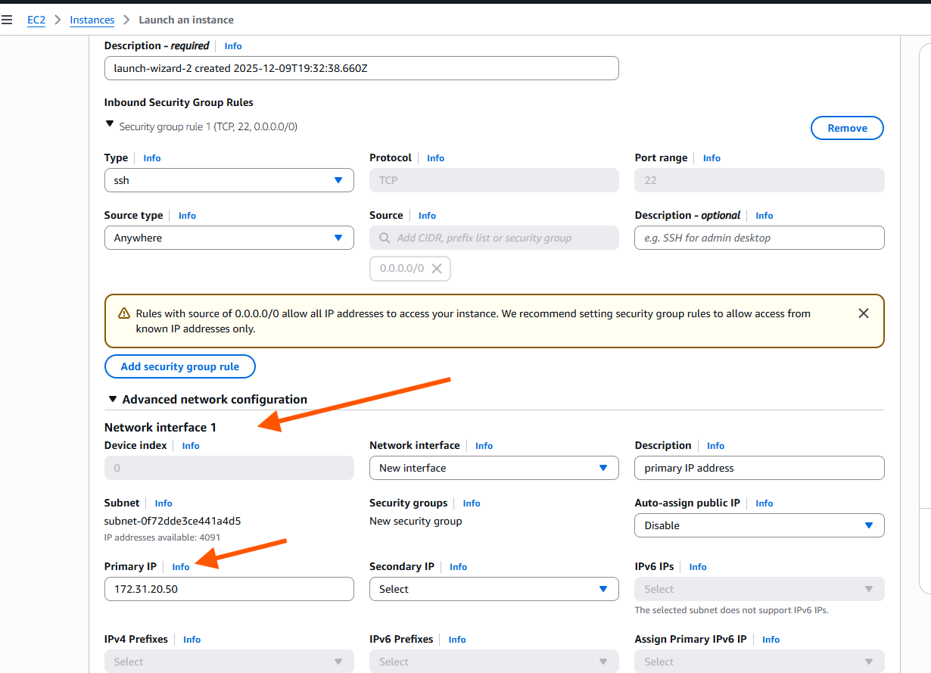

Step 4: Continue and Launch EC2
Now your instance will launch with:
- Primary private IP → 172.31.20.50
This becomes the permanent primary IP (cannot change later).
PART 2 — Add Secondary Private IP After Launch
(If the instance is already created and you want an additional IP)
Step 1: Go to the running instance
EC2 → Instances → Select your EC2
Step 2: Open Network Interface
Scroll down to:
Networking → eth0 (Primary ENI)
Click the Network Interface ID.
Step 3: Assign a secondary IP
In the ENI page:
- Click Actions
- Choose Manage IP Addresses
- Click Assign new IP
- Enter your desired IP, example:
172.31.20.51
- Save
Now you have:
- Primary IP → (original AWS-assigned one)
- Secondary IP → 172.31.20.51

